EXP NO:03 DATE:
DESIGN OF WEIN-BRIDGE OSCILLATOR USING LT SPICE
AIM
To Design a Wein-Bridge oscillator, simulate it in LTspice to verify frequency of oscillation, and implement it on a breadboard to confirm waveform generation.
SOFTWARE REQUIRED
- LTSpice Simulator
Theory

The Wein-bridge Oscillator generally finds its prime application in audio frequency range. It is also preferred for low frequency applications. The Wein bridge Oscillator uses a lead lag network as a feedback network. At very low frequencies, the phase angle is positive and the circuit acts like a lag network. In between, there is a resonant frequency with 0º phase shift. The lead lag network acts as a resonant circuit. Hence the circuit oscillates to a particular frequency.

Procedure:
- Open LTspice and Create a New Schematic
- Place the Circuit Components
- Wire the Components
- Set Component Values
- Add a Simulation Command
- Place the Simulation Command on the Schematic
- Run the Simulation
- Analyze the results
- Calculate the theoretical frequency
1
f = 2πRC

- Calculate the practical frequency by using step2. f=1/T

DESIGN:

Given Data:
V_{CC} = 12 V, V_{BE}=0.7 V, f = 50hz, Ic = 2mA , h_{fe} = 100

Assume for proper amplification,
Consider
Step 1:

Step 2: To find R_{E} AND R_{C}

Apply KVL to the output Loop,

Step 3: To find R₁ and R₂

According to voltage divider rule,

( For Silicon transistor, VBE=0.7 V)

To avoid the overloading in the circuits, I_{R1}=10I_{B} and I_{R2}=9I_{B}

Step 4: To find capacitance (C_{E} and C_{C})

By Pass Capacitance (C_{E})

Coupling Capacitance (C_{C})

OSCILLATOR DESIGN

Assume f=1kHz, C=0.01µf R=159KΩ (R is approximated to 100 KΩ)

Therefore R = 100 KΩ

Circuit Diagram:

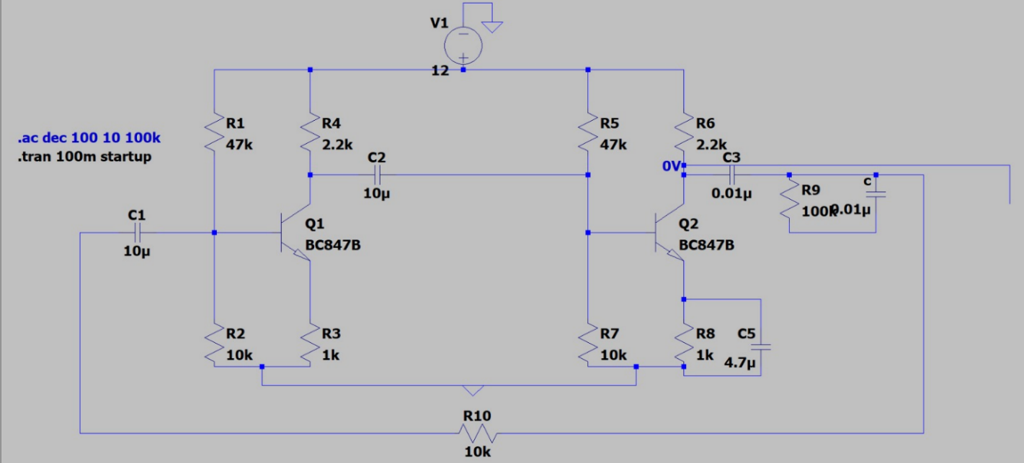

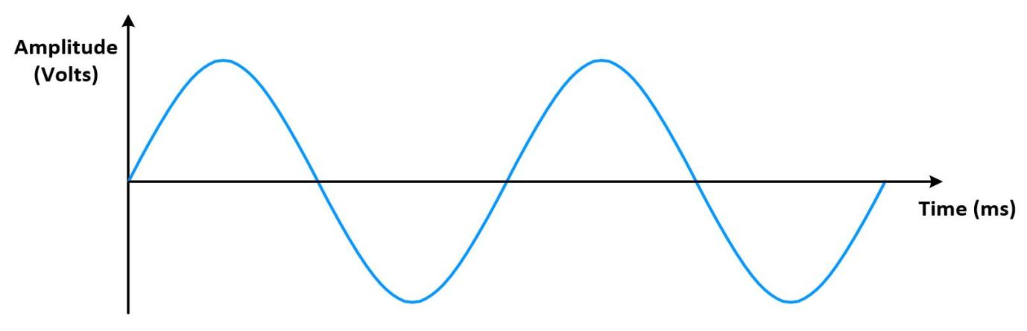
Model Graph
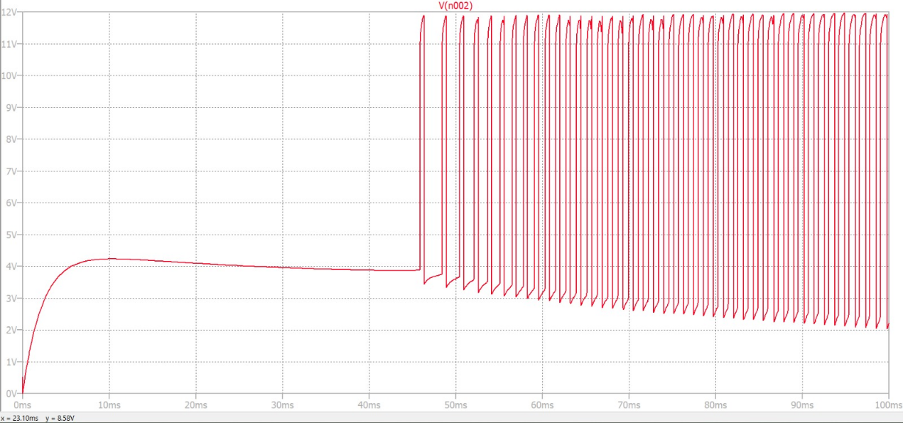

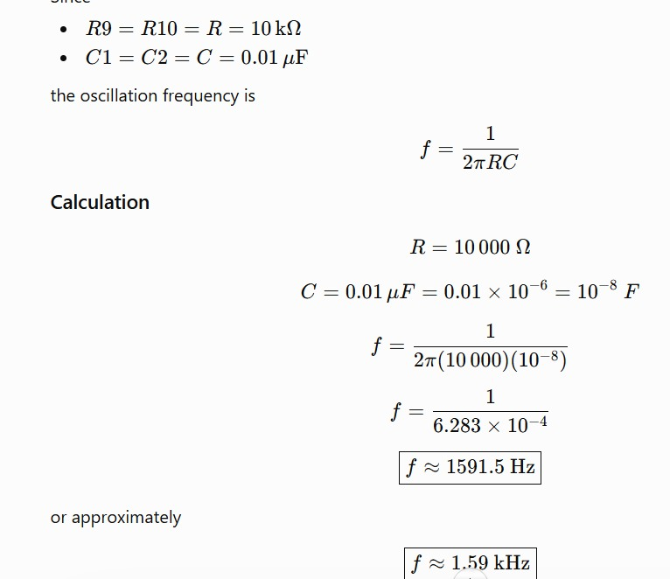
Tabulation:

Amplitude | Time Period | Practical frequency | Theoretical frequency

RESULT:
Thus the wein bridge oscillator was designed and simulated using LTspice and constructed for the given cut off frequency.

Theoretical frequency=
Practical frequency =

